Hart Publishing is delighted to give you information about their latest titles

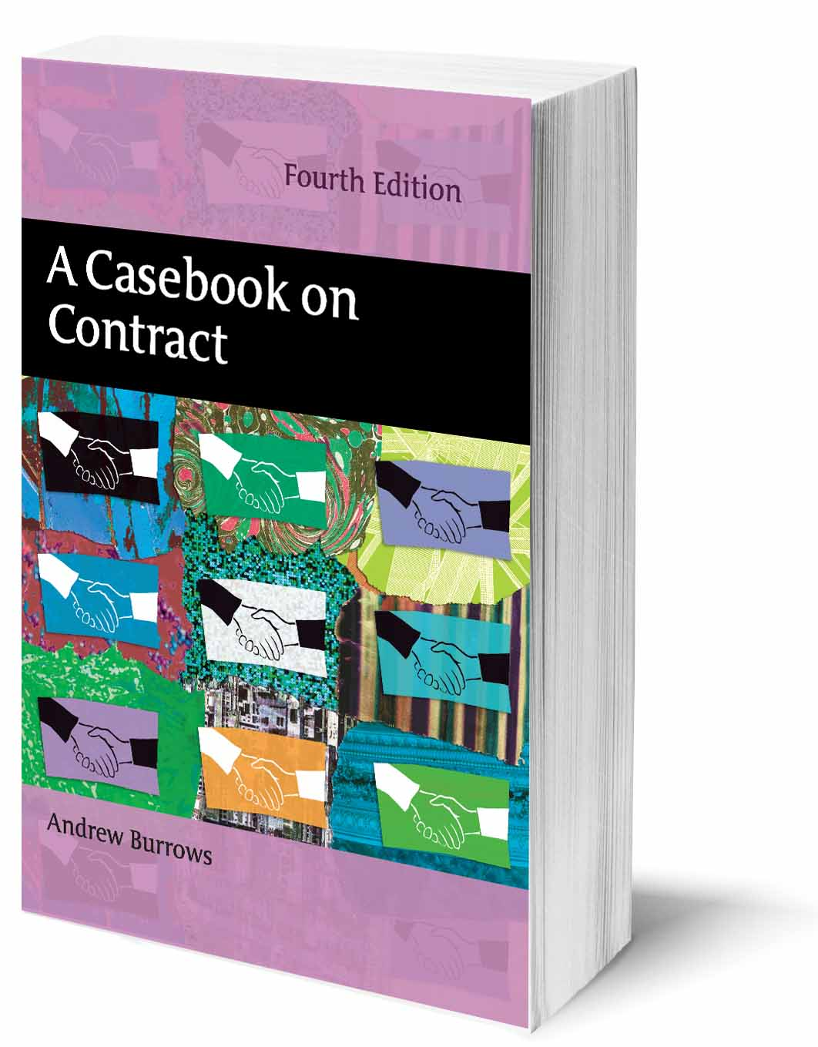
NEW 4TH EDITION
A Casebook on Contract
By Andrew Burrows

Praise for previous editions:
“Excellent update. Continues to be the best Text, Cases and Materials volume out there.” Jeremias Prassl, St John's College, Oxford

“The most up-to-date text. Student friendly…Excellent coverage of the case law.” Dr Benjamin Andoh, Southampton Solent University, Law School

“An outstanding casebook: concise extracts that capture all relevant aspects, clear and helpful comments, and up-to-date and well-selected suggestions for further reading.” Florian Wagner Von Papp, University College London

“Probably the best and most straightforward text, with very good commentary and overview of further reading''
Ewan McGaughey, King's College, London

"…simply excellent, as it has case comments and insightful questions…to work out tutorial problems Burrows is essential." Anca Chirita, Durham Law School

"Clear, comprehensive, incisive and up-to-date." Professor Joshua Getzler, St Hugh's College, Oxford

This is the fourth, fully updated, edition of Professor Burrows' casebook, offering law students the ideal way to discover and understand contract law through reading highlights from the leading cases. Designed to be used in conjunction with a contract law textbook, this book covers the undergraduate contract law course in a series of clearly presented and carefully structured chapters. The author provides an expert introduction to each topic and his succinct notes and questions seek to guide students to a proper understanding of the cases. The relevant statutes are also set out along with a principled analysis of them. In addition to cross-references to further discussion in the leading textbooks, an innovative feature is the summary of leading academic articles in each chapter. The book is designed not to overwhelm students by its length but covers all aspects of the law of contract most commonly found in the undergraduate curriculum.

Andrew Burrows, MA, BCL, LLM (Harvard), QC (Hon), FBA, Barrister and Honorary Bencher of Middle Temple is Professor of the Law of England in the University of Oxford and a Fellow of All Souls College. He has been a Law Commissioner for England and Wales, a lecturer at the University of Manchester and Professor at University College, London. He lectures regularly for the Judicial College, is a Recorder on the South-Eastern Circuit and a Door Tenant of Fountain Court Chambers, London. His other books include Remedies for Torts and Breach of Contract, The Law of Restitution, and Understanding the Law of Obligations. He is a joint author of Anson' s Law of Contract, the general editor of English Private Law and an editor of Chitty on Contracts and Clerk and Lindsell on Torts.

June 2013 898pp Pbk 9781849464468 RSP: £28.95
Discount Price: £23.16

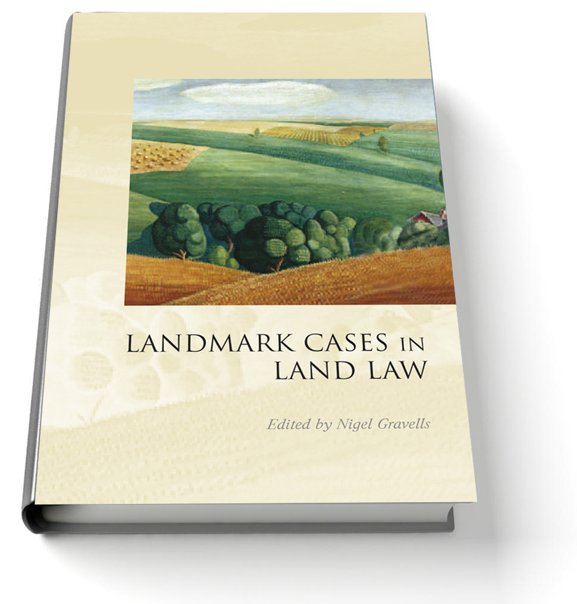
Landmark Cases in Land Law
Edited by Nigel Gravells

Landmark Cases in Land Law is the sixth volume in the Landmark Cases series of collected essays on leading cases (previous volumes in the series having covered Restitution, Contract, Tort, Equity and Family Law). The eleven cases in this volume cover the period 1834 to 2011, although, interestingly, no fewer than six of the cases were decided or reported in the 1980s. The names of the selected cases will be familiar to property lawyers. However, individually, the essays provide a reappraisal of the cases from a wide range of perspectives - focusing on their historical, social or theoretical context, highlighting previously neglected aspects and even questioning their perceived importance. Collectively, the essays explore several common themes that pervade the law of property – the numerus clausus principle, the conclusiveness of registration, the desirability of certainty in the law and the central question of the enforceability of interests through changes in ownership of land. This volume provides a collection of essays that will be of interest to academics, students and practitioners.

Nigel Gravells is Professor of English Law at the University of Nottingham.

June 2013 304pp Hbk 9781849462570 RSP: £60
Discount Price: £48

As a member of the Obligations Discussion Group Hart Publishing is delighted to offer you 20% discount.
ORDER ON-LINE
Please click on the link below each title to order online. When ordering online please type the reference 'ODG' in the voucher code field and click ‘apply’ to receive the discount.

Alternatively, please contact Hart Publishing and quote reference ‘ODG’ to receive the 20% discount.
Hart Publishing Ltd, 16C Worcester Place Oxford OX1 2JW, UK
Tel: +44 (0)1865 517530 Fax: +44 (0)1865 510710
E-mail: mail@hartpub.co.uk; Website: http://www.hartpub.co.uk

